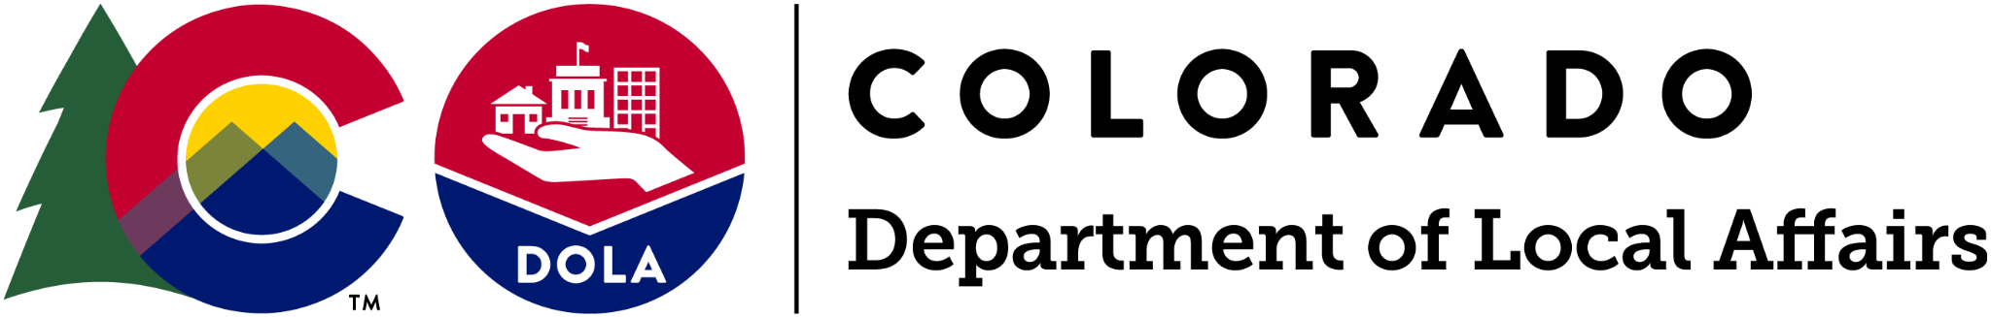
IMMEDIATE RELEASE

The Department of Local Affairs, Through the Regional Access Partners Network, Seeks Applicants for the Nonprofit Infrastructure Grant Program

Leer en Español | STATEWIDE – May 25, 2023 – The Department of Local Affairs (DOLA) announced the Nonprofit Infrastructure (NPI) Grant Program, a statewide grant program for small, community-based, nonprofit organizations providing services to communities who have historically been underrepresented, underserved, or under-resourced.

The Department of Local Affairs (DOLA), through the Regional Access Partners Network, seeks small nonprofit applicants, with annual budgets between $150,000 and $2,000,000, that have been affected by the infrastructure aftermath of COVID-19. While the grant is not for programming, it does open doors for other opportunities such as strategic planning, professional development for board and staff, technology, etc.

The application will open on July 5, 2023 and close on August 31, 2023.

The Nonprofit Infrastructure Grant Program

The Nonprofit Infrastructure Grant was created after the Colorado House Bill 22-1356 was signed into law on June 3, 2022, to help underrepresented communities with limited access to state and federal funding and those impacted and disproportionately impacted by the pandemic. The emphasis on infrastructure and capacity building will help small nonprofits build critical staff and boards, while providing funds to proactively invest in the organization’s makeup. The grant is designed for nonprofits in historically-marginalized communities that need more foundational help. $33,100,000 in grants will be awarded - with selected organizations awarded up to $100,000.

Additionally, if a tax-exempt charitable or social welfare group operating under a 501(c)(3) acts as a fiscal sponsor to small community-based groups (SCBG) that are not registered nonprofit organizations, those groups are also eligible for this grant funding.

“The NPI grant is an incredible opportunity for infrastructure and capacity building that will support the state’s small nonprofit community,” said Kodi Johnson, program manager at the Department of Local Affairs. “DOLA is urging qualifying organizations across the state to apply and continue to deepen the impact that nonprofits and their donors have on supporting historically underrepresented, underserved or under-resourced Coloradans.”

How to Apply

To apply, interested applicants should contact their geographically-appointed Regional Access Partner (RAP) directly for technical assistance and to learn more about the process, criteria and funding. RAPs are collaborating with DOLA to help select and administer grants within their particular regions, emphasizing a hyper-local focus on teamwork and support.

Organizations must provide a Unique Entity ID (UEI) number from the federal government and meet the eligibility requirements. Applications are submitted directly through one of the eight Regional Access Partners (RAPs), determined by the location of the organization’s headquarters. Funding is allocated for infrastructure needs only. Grant awardees will be notified by their RAP by January 31, 2024.

“Together DOLA and the RAP network are focused on ensuring that eligible nonprofit organizations in the state are aware of this opportunity,” added Johnson. “It is the Program’s goal to put forth the resources to help nonprofits apply and build capacity and infrastructure post COVID-19.”

For more information about this Program and to find a geographically-appointed RAP, please visit dlg.colorado.gov/nonprofit-infrastructure-grant-program.

# # #

